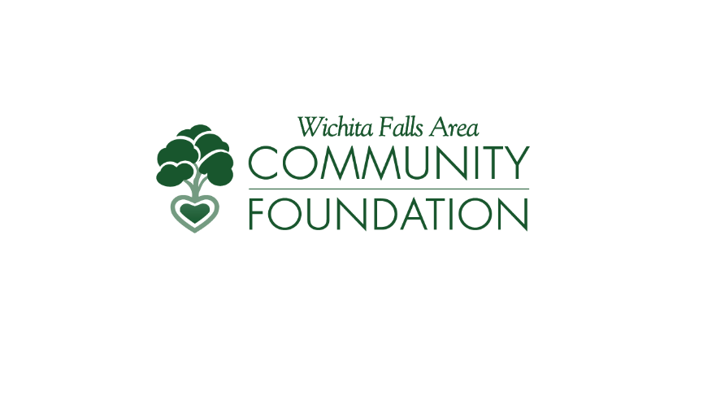

Fund Advisor Portal Guide

The Wichita Falls Area Community Foundation is committed to helping our Fund Advisors access their fund(s) and request grants as smoothly and efficiently as possible. The Community Foundation uses an online Portal to provide a secure and easy way to manage your fund. Depending on the type of fund you advise, you may be able to view the latest fund balances, make grant recommendations, or review gift history. **The information provided below is meant to help you navigate the recent changes to the Fund Advisor Portal.** We are available to help, so please give us a call at 940.766.0829 for extra assistance.

# Logging into the Fund Advisor Portal

1. You can choose either:
   1. Go to <https://wichitacf.fcsuite.com/erp/portal>

**OR**

* 1. Go to our website at [www.wfacf.org](http://www.wfacf.org), click the “login” button, and then select “Fund Advisor Login”

1. If your screen looks like this, you are in the right place:

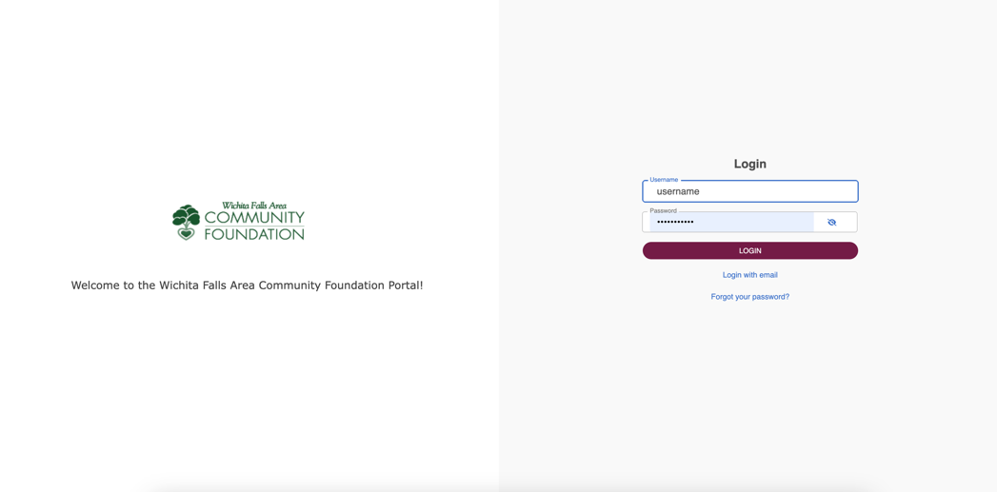

1. Log in using your current username and password – no username or password changes are required
   1. If you do not have a login or receive an error message, please contact us at 940.766.0829 or [wfacf@wfacf.org](mailto:wfacf@wfacf.org).

# Advising Multiple Funds

If you advise multiple funds, all of your funds will be listed on the home page of the Portal. Select the fund account you are wanting to manage.

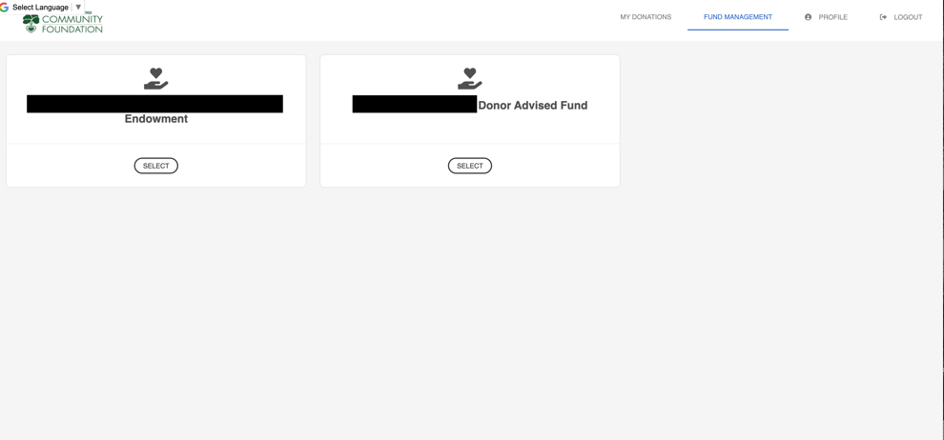

# Tab Selections

After selecting the Fund you wish to manage, you will be taken to your Fund Summary where can select the tabs on the left-hand side of the page to review different areas available to you as a Fund Advisor. The tabs will vary depending on your type of fund (i.e. scholarship or donor advised).

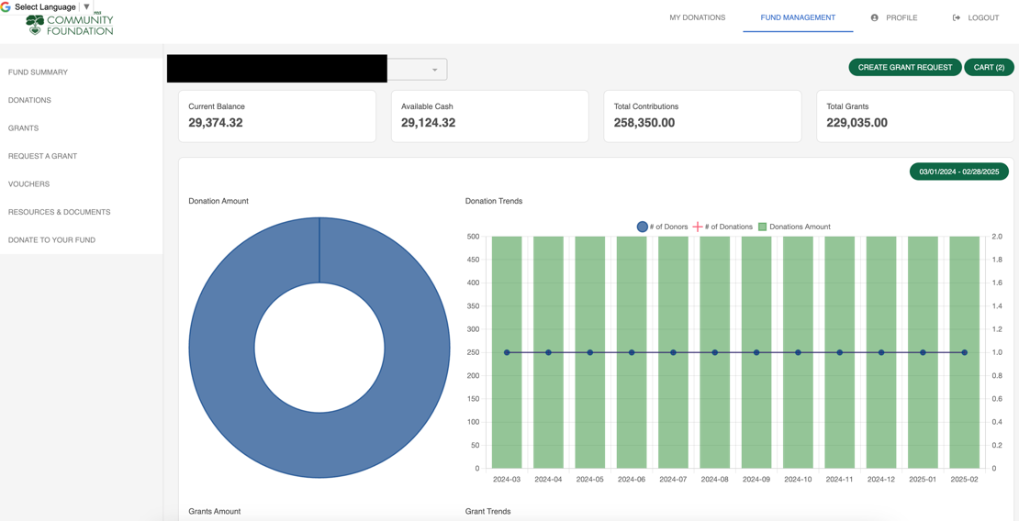

* **Fund Summary** 
  + This tab provides the fund’s current balance, total grants and contributions, as well as a series of charts to see fund activity.
* **Donations** 
  + If applicable, this tab shows the detail for each gift received into the fund. Unless the donor has requested to remain anonymous, you will be able to view more detail about each donor by clicking their name. You can also click the green “export” button on the right side of the screen to export the details into an Excel spreadsheet for your records.
* **Grants** 
  + When you select “Grants,” the top menu will show 3 options:
    1. **Grant summary** lists total cumulative grants by grantee.
    2. **Grant History** lists each individual grant made from the fund, starting with the most recent.
       1. Fundholders can make copies of previous grants by selecting the blue “Copy” button. This will create a new grant request with the same details as the previous grant recommendation.
       2. The grant status reflects where the grant is in the Foundation’s process. “Request” status means that the recommendation has been submitted. “Paid” status means the grant has been paid via ACH or mailed to the grantee. Please contact the Community Foundation if you have questions about the status of a grant.
    3. **Recurring Grants** lists any recurring grants associated with the fund. By selecting the individual recurring grant, the option to edit the recurring grant will appear on the right-hand side.
* **Request a Grant**
  + Depending on the type of fund, you *may* be able to make grant requests from your fund by clicking on the “Request a Grant” tab. Next, you will select the “Create Grant Request” button in the top right-hand corner. Then, you will select from the following 3 options:
    1. **Previous Grantee** 
       1. This selection gives you the option to choose from a grantee you have given to in the past, a Foundation fund you have given to in the past, or other Foundation funds you might want to support.
    2. **Search Grantee**
       1. This selection allows you to search for a grantee based on name, address or EIN. The system will search the Foundation’s database as well as Candid for organizations containing the keywords that you’ve selected. Candid is an information service specializing in reporting on U.S. nonprofit organizations. The more keywords used, the better the search results will be.
       2. Results will be displayed from the Foundation’s database and then Candid.
       3. Please note that this tool does not automatically guarantee that an organization will pass the Foundation’s due diligence, that procedure will still take place during processing.
    3. **Enter a Grantee Manually**
       1. This selection allows you to enter nonprofit or grantee details manually. You will need to enter the name of the grantee, an address, zip code, and a phone number to move the grant request to the Foundation’s staff for due diligence.
  + Once the grantee has been selected, follow these steps:
    1. Complete the form and select “add to cart.”
    2. You can add multiple grant requests if desired.
    3. When done creating grant requests, select the “cart” button in the top right-hand corner.
    4. In the Grant Request Cart, select the “Review Grant Requests” button.
    5. If no changes are needed, select “Submit Grant Requests” at the bottom of the page.
* **Vouchers**
  + This tab is available to review invoices paid to grantees.
* **Resources & Documents**
  + This tab will show current and previous fund statements.
  + Any files related to the fund will also be located here.
* **Donate to Your Fund**
  + The “Donate to your Fund” tab will take you to our donate page pictured below. It will feature your funds and featured WFACF funds. Select the “Donate” button under your fund and follow the steps to donate online.

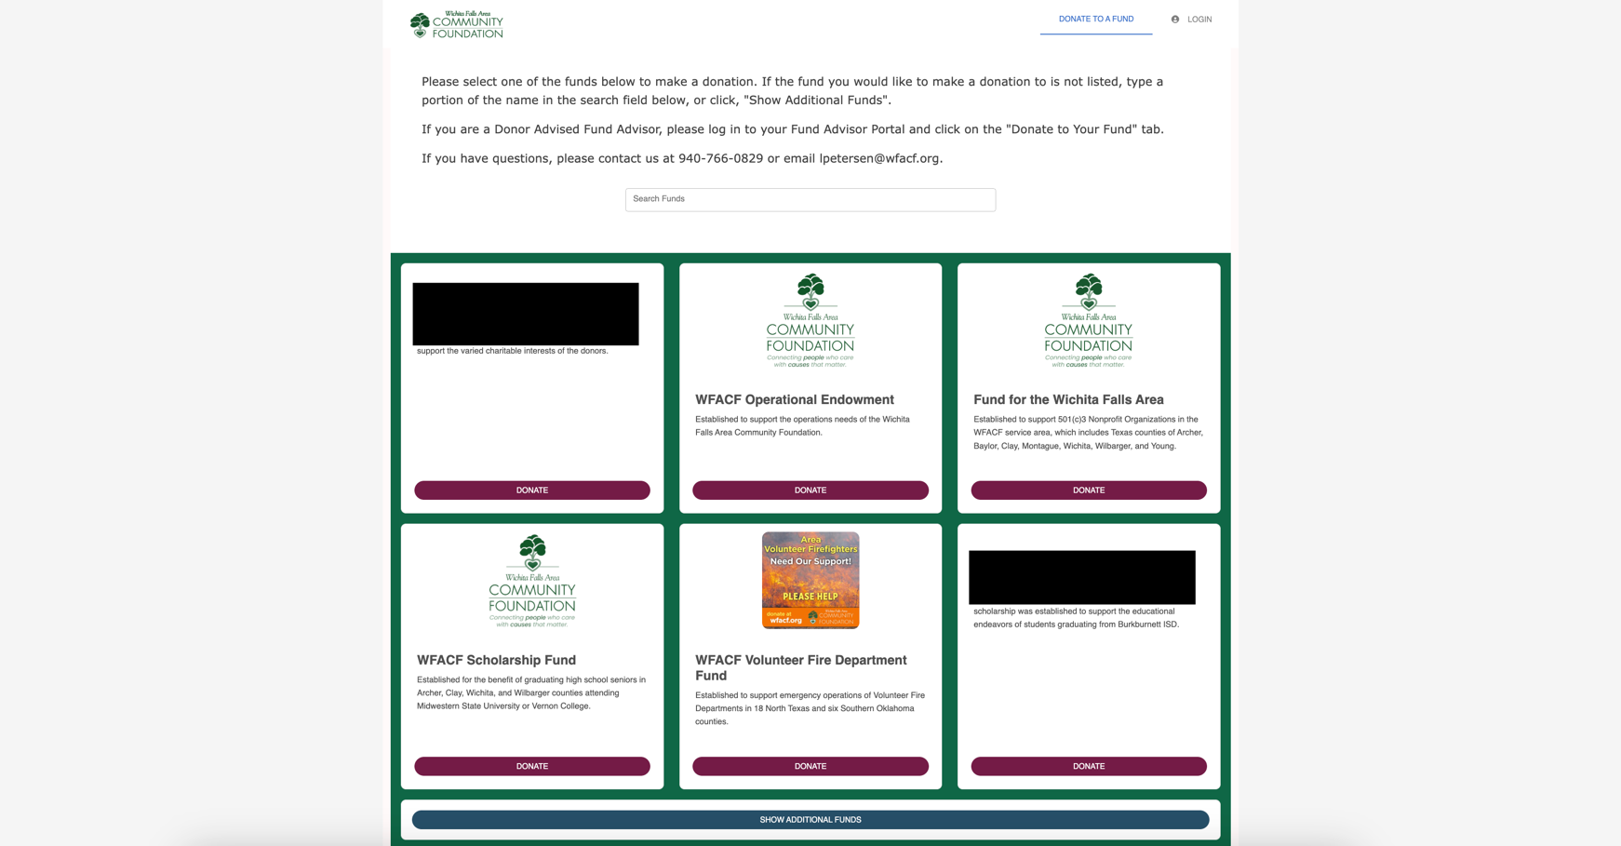

# Log Out of the Portal

Remember to keep your username and password in a safe place for your records. After accessing your fund, please log out each time for safety of your information. Select the “logout” button at the top right-hand corner.

# Locked Out of the Portal?

If you cannot gain access to your account, please contact us at 940.766.0829.

# FAQs

# I want to update my information. Can I do that in the Donor Portal?

* 1. You can update your personal information in the Fund Advisor Portal. Click the profile icon in the upper right-hand corner, then proceed to edit the information. Any changes made in the donor portal will be reflected in the Community Foundation’s records.
  2. Please consider adding your philanthropic interests into the profile section of the portal. This will allow us to contact you to share potential giving opportunities that match your interests!

# I want to update my fund’s information. Can I do that in the Portal?

* 1. If you want to update details for the fund (such as name, investment portfolio, or those associated with the fund) please contact us at 940.766.0829 or wfacf@wfacf.org

# How will I know if I submitted a grant successfully?

* 1. You can check the status of the grant in the donor portal, on the “Request a Grant” tab. You should receive an emailed grant confirmation once the grant has been posted and mailed to the grantee.

# How long does it take to process a grant recommendation?

* 1. Grant recommendations received will be in the queue for due diligence review and processing. Grants are distributed via ACH twice per month on the Fridays closest to the 15th and the end of the month.

# How will I know when my grant is processed?

* 1. All fund advisors will receive an email notification when a grant is posted and mailed. You can always check the status of a grant in the Fund Advisor Portal.

# On what devices may I access the Portal?

* 1. The new Fund Advisor Portal is compatible with most devices that can access the internet through a browser (e.g. your smartphone, tablet, and PC). However, there is no separate app for the system.
  2. The best browser to use is Google Chrome.

# Can I find my tax receipts in the Portal?

* 1. Acknowledgement Letters (Tax Receipts) are saved in the “Resources & Documents” tab on the left-hand side of the Portal. Fund Statements also include this information.

# How quickly will my donation show up in my Fund Advisor Portal?

* 1. The Community Foundation will process your gift in 7-10 business days. During certain peak periods, such as the end of the calendar year, gift processing may take longer than normal to complete. Online donations will immediately show up in the Portal.